From Static to Dynamic: Parameter Manipulation as Adaptive DDL Scaffolding in L2 Creative Writing with Generative AI

YU Ruobin^{1,2*}
^{1*} Department of English, Hong Kong Baptist University, 224 Waterloo Road, 999077, Kowloon Tong, Hong Kong.

*Corresponding author. E-mail: 24484008@life.hkbu.edu.hk

Abstract

Generative AI tools now pervasively integrate into educational contexts, yet the field lacks empirical understanding of how technical AI configurations translate into adaptive Data-driven Learning (DDL) scaffolding. This gap is especially critical in L2 creative writing where excessive structure diminished authorship and insufficient support suppresses creative exploration. This research addresses this gap by investigating how LLM parameter configuration can function as a pedagogically design lever for DDL scaffolding. The work hopes to contribute to DDL by rendering parameter effects explicit and measurable, enabling educators to design responsive AI systems that dynamically adapt scaffolding to learner needs and creative goal.

Key Words: Data-driven Learning; AI parameter configuration; L2 creative writing; Adaptive scaffolding; Human-AI collaboration.

Introduction

With the rise of generative AI, scholars pose a challenge to the language teaching profession: Generative AI, allowing learners to bypass the inductive pattern discovery processes, represent the death of Data-driven learning (Crosthwaite & Baisa 2023). This paper argues that generative AI might represents an evolution rather than replacement of DDL principles. We examine this proposition through AI-assisted L2 creative writing, where the tension between DDL principles and generative AI becomes visible.
Data-Driven Learning (DDL), put forward by Johns (1991) as “the use of concordance data in language learning,” has long valued inductive pattern discovery over deductive rule presentation. By engaging learners directly with corpus, DDL transforms language pedagogy from teacher-transmitted knowledge to learner-discovered insights (Boulton 2012). The pedagogical power of DDL lies in its emphasis on learner autonomy and evidence-based discovery. These are the principles that align closely with constructivist learning theory and sociocultural approaches to second language acquisition (Lantolf & Thorne 2006).
Yet, to answer whether AI-assisted writing truly constitutes DDL, we must first challenge outdated conceptions of DDL as merely “keyword matching” or “concordance consultation” (Sinclair 1991). At its core, DDL represents data-driven decision making in language learning, which means making pedagogical choices in patterns observed in language corpus. Traditional DDL accomplished this through explicit corpus queries and concordance searches, a relatively low-tech approach where learners typed keywords and examined frequency lists (Cobb 2013).
Large language models, on the other hand, are trained on massive language corpora consists of billions of words, it learns patterns through machine learning and neural networks that identify regularities in how language actually works (Vaswani et al. 2017; Radford et al. 2019). When AI generates a poetic line or suggests an alternative phrasing, it applies these learned patterns, making the process inherently data-driven even though it occurs through neural network inference rather than the explicit corpus queries familiar from traditional DDL.
In terms of collaborative creative poetry writing, the procedure combines student decisions (input about theme, emotion, style, form) with AI’s pattern-based text generation. Students exercise agency in conceptual and creative dimensions while AI provides pattern-informed linguistic scaffolding, paralleling how traditional DDL learners formulate queries (student agency) and receive pattern-based evidence (corpus data). Therefore, both traditional DDL and AI-assisted DDL, though using different technological mechanisms, are fundamentally data-driven learning.
Traditional DDL positions learners as active query initiators who must formulate search criteria, execute corpus queries, and interpret concordance results. This learner-driven approach, while fostering autonomy, imposes considerable cognitive demands: sufficient metalinguistic awareness to know what to search for; technical competence to navigate corpus interfaces; and the patience to tolerate data ambiguity and information overload (Sun & Wang 2003). Moreover, corpus data, by its very nature, represents patterns of what has been written, not necessarily what could be written, which is a limitation that becomes constraining in creative writing where novelty, surprise, and originality are pedagogical goals.
Generative AI transforms this dynamic by enabling system-initiated pattern presentation. Rather than learners laboriously searching corpora for patterns, AI proactively generates poetry lines, phrases, or corrections that instantiate linguistic patterns, making them visible to learners through the creative writing process itself. This shift from learner-initiated queries to system-initiated presentations represents a fundamental reconceptualization of DDL:
In traditional DDL, learners decide what to search for, when to query the corpus, and how to interpret concordance results. The corpus remains passive, learner agency drives the discovery process. In AI-assisted DDL, The system decides when to intervene, what patterns to present through generated text outputs, and how to frame linguistic information. AI actively shapes the learning trajectory through real-time responds.
This transformation might addresses traditional DDL’s cognitive overload and technical barriers (Bernardini 2004; Crosthwaite&Baisa 2023) by providing scaffolded, contextualized pattern engagement rather than requiring learners to independently search large corpora. However, it also introduces critical questions: How can AI-mediated pattern presentation be dynamically adapted to provide appropriate scaffolding in L2 creative writing?
Firstly, we have to distinguish L2 poetry writing from traditional or professional poetry writing which involves a holistic process where writers move from ideation and emotional expression through theme selection, word choice, text generation, and revision. While experienced poets integrate these phases seamlessly, L2 learners often struggle with the execution phase despite having clear ideas and emotional content to express. This painful gap between creative intention and linguistic execution creates a barrier that stops many learners from engaging in poetry writing in the first place.
Secondly, L2 poetry writing has distinctive pedagogical goals that differ significantly from teaching poetry as a literature course. While literature courses emphasize aesthetics, originality, and meaning, L2 poetry pedagogy emphasizes language development through engagement with sound patterns, lexical choices, grammatical structures, and linguistic expressivity (Hanauer 2010; Lao & Krashen 2000). Thus, AI scaffolding for developing linguistic pattern sensitivity may differ from scaffolding designed to cultivate personal artistic voice.
Overall, L2 poetry pedagogy faces persistent practical constraints such as: limited access to diverse exemplars reflecting learners’ cultural and linguistic backgrounds; insufficient individualized feedback on language use patterns; and constrained exploration opportunities when learners fear grammatical errors or uncertain expression. These challenges create pedagogical gaps that AI technologies might potentially address.
The use of generative AI for poetry writing represents an emerging area of research with rapidly evolving pedagogical implications. AI-assisted writing systems might offer four complementary solutions to L2 creative writing scaffolding challenges:
First, AI functions as model provider, generating diverse stylistic exemplars that prompt learners to articulate and defend poetic choices explicitly, supporting meta-cognitive dimensions of creative development (Chakrabarty et al., 2022); Second, AI serves as creativity explorer, enabling serendipitous discovery through unexpected suggestions that trigger creative insights beyond solitary writing capacities (Boden, 2004; Coenen et al., 2022); Third, AI operates as tutor bridging the gap between creative intention and linguistic execution, preserving learner agency in conceptual decision-making, providing pattern-based scaffolding for L2 linguistic realization. Fourth, AI functions as pattern recognizer, leveraging sophisticated capacity to manipulate linguistic patterns across phonetic, syntactic, semantic, and aesthetic dimensions simultaneously (Holtzman et al., 2019; Li et al., 2025; Peeperkorn et al., 2024), enabling L2 learners to experiment with forms and effects they might not master through traditional study alone while developing sensitivity to English’s poetic patterns.
However, language educators lack empirical understanding of how to configure AI as a pedagogical design supporting L2 students’ creative development. Questions such as “How should AI be configured to scaffold authentic creative voice while supporting linguistic development?”, “What interaction types between students and AI systems promote deep engagement with poetic form and meaning?”, and “How do parameter configurations affect learner authorship and creative agency in L2 poetry contexts?” remain largely unexplored.
This study tries to address this pedagogical gap by investigating how educators can harness AI’s structural understanding and generative capacity to support L2 students’ own creative discovery and voice development. By examining how parameter configuration shapes interaction patterns and learning outcomes in authentic L2 poetry writing contexts, we contribute essential evidence for technology-mediated language pedagogy that current literature does not provide.
We propose a “three-interaction-types framework” that integrates DDL principles, scaffolding theory, and human-AI collaboration research. Recent studies provide empirical foundations: Coenen et al. (2022) identified “serendipitous discovery” as crucial for productive human-AI collaboration; Qian et al. (2023) demonstrated AI’s capacity to redistribute cognitive load; Li (2025) found that generative AI shifts writers toward strategic collaboration. However, these studies treat AI as monolithic rather than examining how different AI configurations produce distinct interaction patterns with different pedagogical affordances.
Our framework addresses this gap by revealing the mechanism through which AI can dynamically adapt scaffolding: parameter configuration (specifically temperature and top-p settings) systematically shapes interaction type distributions. Lower parameter values (e.g., temperature 0.3, top-p 0.4) produce deterministic, corpus-typical outputs aligned with training data patterns; higher values (e.g., temperature 0.8, top-p 0.9) generate variable, exploratory outputs extending beyond corpus frequencies (Holtzman et al., 2019; Li et al., 2025; Peeperkorn et al., 2024). This technical mechanism enables pedagogical adaptivity: parameter manipulation functions as a design lever for shifting between different DDL-scaffolding modes.
We theorize three interaction types as “parameter-dependent DDL-scaffolding modes”, each serving distinct pedagogical functions:
Type A Constraint Repair: AI identifies deviations from linguistic or structural patterns and provides corrective guidance. This parallels traditional DDL’s use of concordance lines but occurs proactively rather than through learner-initiated queries. Type A represents normative pattern reinforcement, helping learners master formal requirements like syllable counts or grammatical accuracy. Low parameter values (temperature 0.3, top-p 0.4) maximize Type A by constraining outputs to corpus-typical patterns, providing heavy scaffolding but potentially stifling creative outputs (Ferris, 2004).
Type B Exemplar Giving: AI provides model phrases or line alternatives that learners select and adapt, aligning with imitation-transformation pedagogy (Hanauer, 2010). Type B reduces cognitive load by offering concrete starting points and diverse stylistic models. Type B involves moderate directiveness and moderate autonomy, supporting accessibility but risking passive selection over active creation.
Type C Surprise Harvest: AI generates unexpected ideas, metaphors, or directions that learners would not discover through conventional corpus consultation, aligning with serendipitous discovery (Coenen et al., 2022) in human-AI co-creativity and resonates with theories of divergent thinking and the role of novelty in creative processes (Boden, 2004). High parameter values (temperature 0.8, top-p 0.9) might increase Type C frequency, enabling AI to function as pattern-extender rather than pattern-reinforcer. Type C is low-directive and high-autonomy, providing light scaffolding that supports creative expansion while demanding critical judgment from learners.
This parameter-interaction relationship has profound implications. Parameter configuration shapes whether AI functions as corrective tutor (Type A), exemplar provider (Type B), or creative collaborator (Type C), directly impacting learner agency and the inductive discovery processes central to DDL pedagogy.
Our research is guided by three questions:

RQ1: How do different parameter configurations appear to affect the distribution of interaction types (Constraint Repair, Exemplar Giving, Surprise Harvest) in AI-assisted L2 poetry writing?

RQ2: How do these interaction types potentially influence L2 learners’ learning experience, creative agency, and satisfaction in collaborative poetry writing?

RQ3: What are the potential pedagogical implications of parameter configuration as a design lever for adaptive DDL in L2 creative writing?

Methodology

Research Design

We designed and deployed a poetry writing platform (poetry.aitutor.ink) that transforms the theoretical framework established in our introduction into a living experimental environment.
The web-based platform features a prompt-designed chatbot system with two critical design principles distinguished from commercial AI tools: 1) Commercial AI tools typically position themselves as content generators. Through careful prompt engineering, we constrained the AI to function as a guide rather than ghostwriter. 2) Where commercial AI tools treat parameters as trade secrets, our platform exposes them as manipulable pedagogy. We engineered the system to function as both learning environment and research instrument. In this way, we can trace the causal pathways through which technical configurations translate into learner experiences.The platform was built using Lovable with OpenRouter API integration, enabling access to GPT-4 as the underlying language model while maintaining full control over generation parameters.
We crafted prompts that would govern AI behavior across chatrooms, making it impossible to discern whether observed variations stem from how the AI is configured (parameters) or what it is instructed to do (prompts). By holding the prompts while manipulating parameters, we created a clean experimental contrast where differences in interaction patterns could be attributed to different scaffolding strategies under various parameter conditions.
Our prompt defines the chatbot’s role as a poetry writing assistant for L2 learners (CEFR B1-B2 proficiency) and establishes response frameworks supporting all three interaction types:
Type A (Constraint Repair): Diagnostic feedback on structural, linguistic, or poetic elements requiring attention;
Type B (Exemplar Giving): Model texts, phrase alternatives, and curated options for learner selection and adaptation;
Type C (Surprise Harvest): Creative suggestions, unexpected metaphors, and generative possibilities extending beyond learner’s initial ideas.
The prompt establishes clear conversational boundaries, while encouraging diverse creative perspectives. Rather than positioning the AI as a corrector, the prompt frames it as a collaborative partner in the learner’s creative process.
By establishing two chatroom with different parameter conditions, we re-conceptualizes temperature and top-p as pedagogical design instruments that educators can use to scaffold:
Structured Chatroom: The Steady Guide (in low parameters condition)
Temperature: 0.3 | Top-p: 0.4
Technical function: Tightens the AI’s decision-making scope, producing predictable, corpus-typical outputs.
DDL function: Transforms the AI into a proactive tutor, surfacing linguistic patterns that learners would encounter through traditional corpus searches, but delivering them contextually and conversationally.
Scaffolding function: Generates a teaching style that might be dominated by Type A normative corrections (“This line needs a stronger verb”) and Type B conventional exemplars (“You could try ‘whispers’ instead of ‘says’”), creating heavy scaffolding that reduces cognitive load but risks constraining creative autonomy.
Exploratory Chatroom: The Creative Catalyst (in high parameters condition)
Temperature: 0.8 | Top-p: 0.9
Technical function: Loosens the AI’s generative constraints, sampling from broader, more diverse token distributions, enabling outputs that deviate creatively from corpus norms.
DDL function: Generating linguistic possibilities that transcend training data frequencies.
Scaffolding function: Shifts the interaction ecology toward Type C exploratory divergence (“What if rain becomes hunger in your metaphor?”), providing light scaffolding that sparks creative expansion.
This parameter-interaction design reveals the mechanism through which AI can dynamically adapt to its pedagogical circumstances, transitioning from structured tutor to exploratory partner simply by adjusting two numerical values. The how of dynamic DDL scaffolding, theorized but yet empirically demonstrated, becomes operationally tractable.
This study employed a three-phase design investigating AI-mediated DDL scaffolding across controlled experimental and naturalistic classroom contexts:
Phase 1: 2×2 Factorial Experiment (N=10)
Design: Controlled laboratory-style experiment manipulating two independent variables:
1. Parameter Configuration (Between-subjects)
Structured: Temperature 0.3, Top-p 0.4 (Rooms A & B)
Exploratory: Temperature 0.8, Top-p 0.9 (Rooms C & D)
2. Awareness Condition (Between-subjects)
Aware: Participants are aware the parameters and their potential effects (Rooms A & C)
Unaware: Participants don’t know about the parameter or their effects (Rooms B & D), serving as control group for isolating genuine parameter effects uncontaminated by demand characteristics.
This factorial design enabled examination of direct parameter effects (structured vs. exploratory) and meta-cognitive influences of parameter literacy (aware vs. unaware), addressing research questions about both technical mechanisms and learner perceptions under controlled conditions.
Phase 2: Natural Classroom Environment : Offline In-Person Workshop (N=8)
Design: An offline in-person classroom setting where participants self-selected into parameter conditions based on personal preference and creative goals.
This phase investigated how learners engage with AI-assisted poetry writing when given agency in a traditional classroom setting, examining the validity of Phase 1 findings while exploring how self-selection of parameter conditions affect creative outcomes, authorship perception, and interaction patterns. 8 L2 learners from Hong Kong Baptist University enrolled.
Phase 3: Natural Classroom Environment: Online Workshop (N=12)
Design: An online learning environment, maintaining self-selected parameter conditions. This phase shifted from face-to-face to remote interaction to test environmental robustness.
This phase extended Phase 2 findings across different learning environments (offline vs. online), examining whether parameter effects and interaction patterns remain consistent when learners engage with the platform remotely rather than in physical classroom settings, exploring how online interaction affects learner engagement and creative development. 12 L2 learners from universities across Hong Kong participated.
The progression from controlled experiment (Phase 1) to naturalistic classroom contexts (Phases 2-3) addresses a critical limitation in educational technology research: findings from tightly controlled laboratory studies often fail to translate to authentic classroom practice. The design strengthens both internal validity (Phase 1’s controlled parameter manipulation) and ecological validity (Phases 2-3’s authentic classroom contexts in different environments).

Context and Participants

We recruited 30 L2 English learners from Hong Kong Baptist University and other Hong Kong Universities through course announcements and digital posters. All participants met CEFR B1-B2 proficiency criteria. Their ages ranged from 18 to 32, with Indian, Thai, Mandarin, and Cantonese L1 backgrounds reflecting Hong Kong’s linguistic landscape. Participants were randomly assigned to experimental rooms, ensuring balanced representation across parameter conditions.

Intervention / Action Plan

All three research sessions unfolded as a 75-minute experience designed to immerse participants in collaborative poetry writing:

Phase 1: Platform Orientation (10 minutes) Participants logged into their assigned rooms (or self-selected rooms in Phases 2-3), familiarized themselves with the chatbot interface.
Phase 2: AI-Assisted Poetry Writing (35 minutes) Participants entered chatrooms where they drafted, revised, and refined poems in conversation with their AI partner.
Phase 3: In-class Reflection Template (15 minutes) Participants responded to reflection on authorship perception, creative satisfaction, and scaffolding experiences.
Phase 4: Panel Discussion (15 minutes) Participants shared their insights on parameter effects, their creative journeys, insights about authorship and collaboration.

Data Collection

We have a multi-modal data which includes five different sources:

1. Complete chat histories from each participants when logging out the chatrooms.
2. Interaction type coding that classified each AI responses according to the three interaction types.
3. Poem artifacts stored in “All Manuscripts” interfaces on the platform.
4. Reflection templates: Participants’ reflection templates which consist of five essential questions: (a) authorship perception (b) creative satisfaction (c) most helpful interaction (d) open-ended AI role descriptions, and (e) preferences for future use.
5. Panel Discussion Transcripts: Discussions that reveals poetic understandings, themes, and emotions which are hard to express in reflection templates.

Data Analysis Plan

Quantitative Analysis
We use the research questions to guide statistical analyses:
RQ1: Do parameter configurations generate distinct interaction type profiles?
We use Chi-square tests to compare Type A, B, and C distributions across structured vs. exploratory conditions, with Cramér's V measuring effect sizes.
RQ2: How do interaction type profiles relate to authorship perception and creative satisfaction?
We use Pearson correlations to examine relationships between each interaction type’s frequency (percentage of total AI responses) and outcome measures.
RQ3: Does awareness of parameter settings moderate parameter-driven effects?
We use Two-way ANOVA with parameter configuration (structured/exploratory) and awareness (aware/unaware) as independent variables tested main effects and interactions on authorship and satisfaction.
All statistical analyses used α = .05 significance threshold with effect sizes (Cohen’s d, Cramér’s V, η²) following APA standards.

Qualitative Analysis
For qualitative analysis, we apply two analytical traditions to examine different facets of creative processes:
Conversation Analysis (Jefferson, 2004): How learners responded to AI suggestions), uptake patterns (active transformation vs. passive acceptance), and scaffolding trajectories (whether support increased, decreased, or remained stable across sessions).
Discourse Analysis: How spontaneous participant characterizations during panel discussions reveals identity (selector vs. co-creator) under different parameter conditions. Metaphors, agency attributions, and evaluative stance are all considered and analyzed.

Ethical Safeguards and Transparency

All participants provided consent before engaging with the platform. Their Chat logs and personal information were stored in separate databases following HKBU IRB protocols, with data retention and destruction procedures clearly communicated.

Results
Through 3 phases of experiment, 1000+ message exchanges, 29 feedback templates, and 60+ minutes of spontaneous discussion transcripts, we conclude the following three results:

- Parameter Configuration Functions as Learner-Intuitive Scaffolding
Learners develop a sense for different AI scaffolding intensities. They intuitively recognizes parameter conditions that align with their evolving creative goals.
- The Type B Paradox: “Helpful but Alienating”
Learner across three sessions generally agreed that type B is the most helpful interaction offered by AI, but they also feel alienated and lack of authorship when receiving the help.
- Type C Might Enable Authentic Co-Authorship Through Iterative Reciprocity
Creativity, authorship and satisfaction emerges from the participants’ critical engagement of rejection, negotiation, refinement, and redirection with AI in poetry crafting.
When we assigned participants in phase one experiment to rooms with fixed parameter settings, the distributional differences is obvious. The structured rooms (T=0.3/Top-p=0.4), where AI behaved as patient tutor, generated interactions dominated by constraint repair (60% Type A) and exemplar selection (35% Type B), with Type C surprise harvest mere 5%. Exploratory rooms (T=0.8/Top-p=0.9), where AI transformed into creative catalyst, changes this pattern. Type C “surprise harvest” interactions increased to 35%, representing a 7-fold increase (χ²=24.3, p<.001, Cramér's V=.38) (See “figure 1”).

Figure 1: Parameter Configurations Influence Interaction Type Contribution
Note. Type C increased to 35% in higher temperature/ top p settings. χ²=24.3, p<.001, Cramér's V=.38

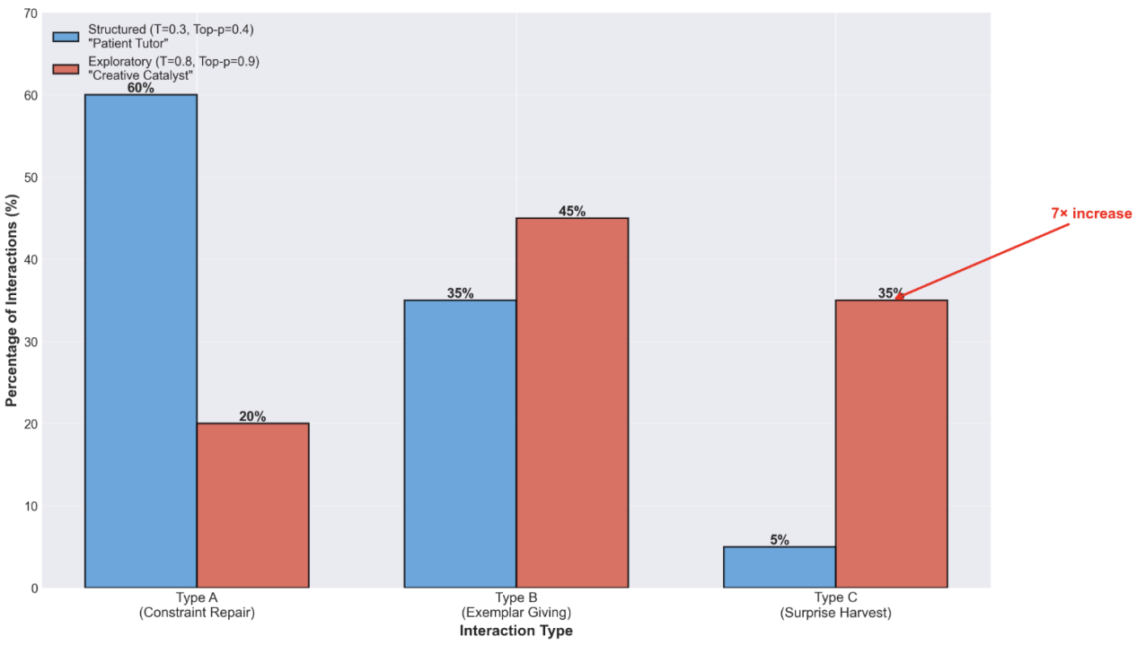
When offering participants autonomous access to both parameter conditions, 75% voluntarily selected Exploratory chatroom for exploring their own creativity, similar to Phase 1’s imposed exploratory distribution. Our final session pushed autonomy further still: no experimental rooms, no guided selection, simply learners exploring the platform as naturally as they might explore any creative tool. 66.7% headed for the Exploratory chatroom, while 8.3% preferred Structured chatroom. 62% demonstrated fluid context-sensitive parameter adaptation, seamlessly switching between modes as their creative needs evolved across a single session.
The convergence across three progressively naturalistic contexts, from imposed assignment, voluntary choice, to autonomous exploration, reveals something essential. Parameter configuration operates not as abstract researcher construct but as phenomenologically real scaffolding dimension that learners can automatically detect, interpret, and strategically deploy. For these patterns to emerge so consistently, parameters create environments sufficiently salient that learners can distinguish them through felt experience alone, not through reading technical specifications or researcher explanations, but through the qualitative texture of AI interactions themselves. The shift from structured to exploratory parameters doesn’t merely alter statistical distributions in coded transcripts; it transforms the phenomenological character of collaboration from “patient tutor” to “imaginative collaborator.”
During Phase 2’s panel discussion, participants spontaneously theorized parameter effects through lived experience, developing phenomenological categories that aligned remarkably with our analytical distinctions:
p 12 (exploratory condition): “It gives me random non-related stuff so I could think more about it”, hinting Type C’s serendipitous discovery function.
p 14 (structured condition): “Multiple options to choose from... very structured, like a menu”, capturing Type B’s exemplar-selection dynamic.
Key Insight: Parameters function as learner-intuitive pedagogical levers, consistently determining which interaction types become available, how learners perceive authorship, and what scaffolding feels appropriate for different creative goals.
Type B interactions, the exemplar-giving, consistently emerged as both pedagogically valuable and creatively alienating. Participants voted Type B “most common” (61.54%) and “most helpful” (55.56%) more than any other interaction type (Type A 19.23% Type C 19.23% for most commonly used type and Type C 33.33% Type A 11.11% for most helpful), acknowledging its frequency and usefulness in AI-assisted writing.

Figure 2: Type B as The Most Frequent and Helpful Interactions Among Three Types
Note. 61.5% participants voted Type B as the most frequently appeared interactions and 55.6% voted Type B as the most helpful.

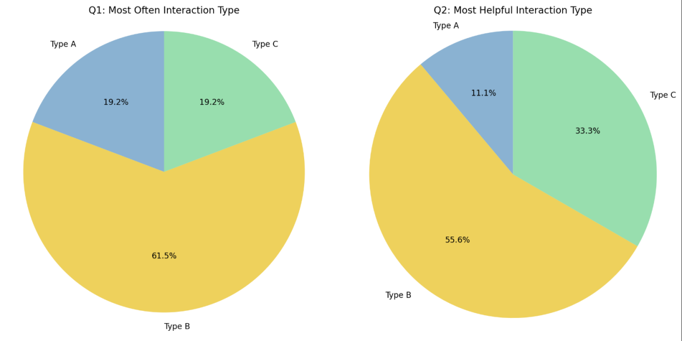
Why participants found Type B “Helpful”？Here are some evidence across three phases of study (see table 1):

Table 1: Participants’ Explanations on Why Type B is the Most Helpful Interaction
Note. We categorized the reasons for favoring Type B into five aspects: 1) Confidence booster 2) Convenient tool 3) Certainty creator 4）Vocabulary support 5) Knowledge gap-filler.

Participants/Phases of experiment | Why Type B is the most helpful interaction type in writing | Quotes from feedback templates and Discussion sessions
P 14 from phase two | Type B as confidence booster | “It (type B) helped me build confidence in choosing words”
P 03 from phase one | Type B as a convenient start for poetry writing | “Because it guided me... and made poem writing easier for me”
P 09 from phase one; p18 from phase two | Type B creates certainty | “It (type B) is clear, all that I need to do is just to choose;” “Because it directly gave me certain options which significantly helped with idea/sentence generation”
P 15 from phase two | Type B as vocabulary support | “...lexical enhancement and vocabulary support”
P 23 from phase three | Type B fills the gap in language knowledge | “It covers the language corner I am not aware of”

Yet those who experienced Type B reported diminished authorship perception and less satisfaction towards the output, creating a tension between utility, creativity and ownership that persisted across every methodological variation.
Participants describing Type B interaction:
p 02: “I do not feel ownership or pride over much of it”
p 05: “It (type B) feels like just AI... I couldn’t feel any sort of creativity”, suggesting the sense of being reduced from creator to content provider, watching the AI transform feeling into verse without genuine collaboration.
p 06: “ After it (type B), the poem became more formulaic,” noticing the loss of emotional authenticity in the translation from expression to formulaic product.
P 17: “Looking at the vocabulary choices (provided by AI), it seems somewhat superficial compared to work by real artists.”
If Type B represents AI as helpful yet alienating collaborator, Type C emerges as something different: AI as a partner in genuine co-creation. Across all three phases, participants who experienced high frequencies of Type C “surprise harvest” claimed substantial authorship (60-96% range) compared to those experienced Type B. They reported more creative satisfaction, and described AI as “partner”.

Figure 3: Authorship Perception Doubled From Type B to Type C
Note: Sense of authorship = Critical engagement, Not word contribution from AI

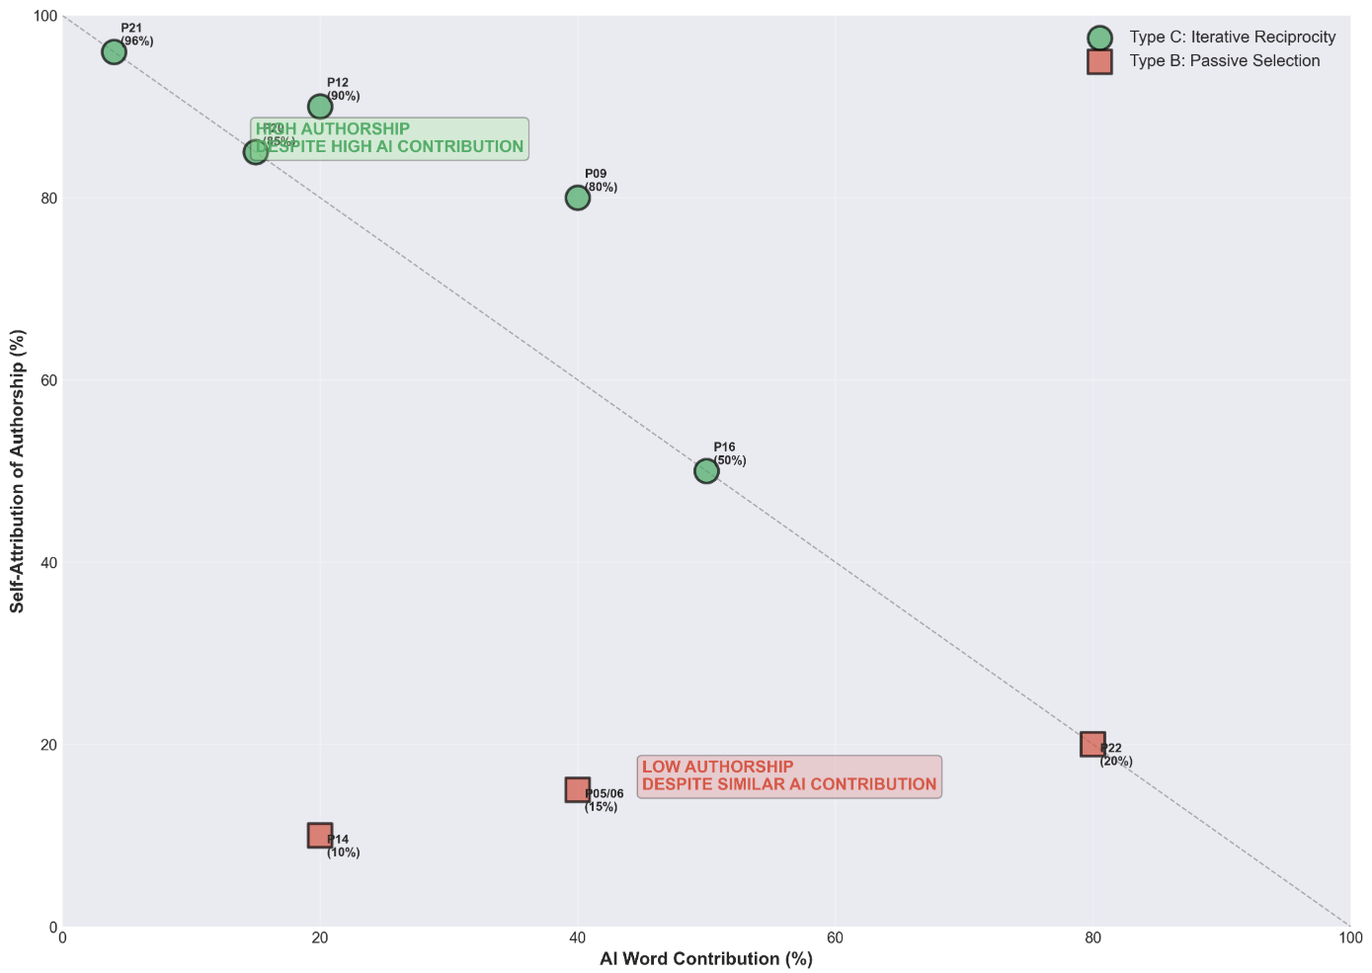

The mechanism proves to be iterative reciprocity: creativity, authorship and satisfaction in writing emerges participants’ critical engagement with AI responses in the process. Here are some evidence:

Phase 1: When Surprise Was Engineered

Chat log analysis revealed p 09 engaged in sustained Type C interactions:
1. Initial conceptual exploration: AI posed philosophical questions about criminal justice reform themes;
2. Craft innovation: AI suggested “found poetry” technique incorporating legal citations;
3. Iterative refinement: AI offered structural feedback while honoring the participant’s creative vision;
4. Authorial control: Participant rejected, modified, and synthesized AI suggestions selectively.
This participant’s authorship rationale (feedback form) shows that: “Yes [authorship matters], otherwise there is no point in the author being involved at all”
Poem Outcome: “Turnstile Justice” is a 15-line experimental piece incorporating legal metaphors, structured stanzas, and emotional interrogation of systemic failures:

Turnstile justice, turnstile court,
Mercy for him, but what of me?
What of us all, sheep among wolves,
A gavel rung, a soothing wave,
But for whom?

An offset sentence, bailed out for naught,
Promises of reform, with rehabilitation,
But the system let them back in, rested,
Bold to this pen of us sheep, who die for this test.

The wolves lunge forth, fresh from the bench,
A culling of those who were never asked,
I weep as I see, turnstile justice,
Whom does it serve?

The poem demonstrates sophisticated craft beyond typical novice work, suggesting Type C interactions can scaffold upward toward advanced competence rather than merely supporting basic production. The Participant Claimed 80% self-authorship.

Phase 2: When the Participants are Critically Engaged

p 12, who chose the exploratory chatroom, claimed 90% self-authorship, the highest ownership perception across all 30 participants, despite AI contributing an estimated 15-20% of the final words. How could such high authorship coexist with substantial AI involvement? The chat logs tell the story through five distinct iterative cycles that reveal the essence of Type C collaboration:
1. Initial creative vision: “I want to write about a cursed princess in dragon form”, giving the conceptual idea/theme, entirely human-generated;
2. AI’s first attempt: Opening lines about transformation and curse;
3. Critical evaluation: “I don’t want receptive use of the word whisper,” rejecting AI’s linguistic choice while accepting the structural approach;
4. AI refinement: Adjusted to “hidden hope,” incorporating feedback while maintaining poetic register;
5. Narrative clarification: “The princess seeks the witch’s help, not vice versa,” correcting AI’s misunderstanding of character agency and plot direction.
p 12 maintained critically engaged throughout, steering AI toward their creative vision through evaluative feedback rather than simply accepting or rejecting complete outputs. Each cycle represented active guidance, not passive selection.
p16 reported a balanced co-creation of 50% self, 50% AI with maximum satisfaction (5/5). During panel discussion, the participant narrated the creative process: “I asked the AI to write about ‘reality hurts.’ Then I instructed it to start from the stage where a person is defeated... From there, I guided it through the next step: training and revenge, and finally to the last step: success.” The verb choices matter deeply: “asked,” “instructed,” “guided,” language of choreography, not consumption. The participant didn’t passively select from AI-generated options; they choreographed the creative arc, with AI providing linguistic and formal realization of human-specified emotional trajectory.

Phase 3: When Type C Brings Creativity

Full autonomy in Phase 3 revealed individual differences in how learners experienced Type C interactions, demonstrating that the same interaction type can serve multiple creative functions.
p 27 (Type C preference) demonstrated that high satisfaction can coexist with modest authorship, the participant reported authorship to be “30% mine, 70% AI.” yet rating AI partnership and emotional safety at maximum (5/5). The explanation explains why: “I’m not a very creative person, but I feel like I can rely on AI to have some sparks in my brain,” valuing AI precisely for cognitive augmentation, treating the collaboration as distributed creativity where AI contributes generative capacity that the human lacks. High AI involvement didn’t diminish satisfaction because the participant experienced it as collaborative enhancement rather than creative displacement.

Discussion

This discussion interprets our cross-phase findings through four lenses: (1) how the Parameter→Interaction→Perception mechanism operationalizes dynamic DDL scaffolding, (2) why the Type B paradox reveals fundamental tensions between surface and deep learning in AI-mediated creative pedagogy, (3) how Type C interactions enable DDL-compatible collaboration through provocation and negotiation, and (4) what these mechanisms suggest for designing AI tools that preserve learner agency while delivers support. Through this analysis, we answer that, DDL’s future might not depend on AI’s capabilities but on educators’ capacity to recognize and exercise pedagogical judgment over AI configuration.
The seven-fold increase in Type C interactions when moving from structured (T=0.3/Top-p=0.4) to exploratory parameters (T=0.8/Top-p=0.9) represents more than a statistically significant finding. It demonstrates parameter configuration as a pedagogical lever with measurable effects. When parameters shift from low to high, AI’s phenomenological character changes from a tutor, enforcing corpus-typical patterns, to collaborator extending beyond predictable conventions. In structured rooms where low parameters constrained AI to high-probability token selections, learners met an AI that behaved as meticulous editor, catching deviations from conventional patterns, offering polished alternatives drawn from training data frequencies, providing linguistic safety nets that prevented errors but also constrained creative risk-taking. The interaction ecology became dominated by Type A constraint repair (60%) and Type B exemplar selection (35%), creating what participants characterized as “grammar checker” (p 06) and “mechanical” (multiple participants) assistance.
In exploratory rooms where high parameters enabled broader token sampling, learners encountered something qualitatively different: an AI that posed philosophical questions about their creative intentions, suggested unexpected craft techniques like “found poetry” incorporating legal citations, ventured creative risks through surprising metaphors, and responded to emotional vulnerability with nuanced recognition rather than formulaic consolation.
This difference operationalizes what traditional Data-Driven Learning might be hard to achieve. Johns’ (1991) DDL vision positioned learners as active “research workers” discovering patterns through concordance interrogation, but engagement intensity remained essentially uniform. Learners encountered whatever patterns their queries surfaced from static corpora. AI-mediated DDL enables system-initiated engagement intensity modulation where parameter settings influence whether learners encounter predominantly corpus-typical patterns (structured parameters prioritizing high-frequency, conventional outputs) or corpus-extending provocations (exploratory parameters sampling from broader, more diverse token distributions).
To understand why Type B helpfulness and alienation coexist, we must examine the cognitive processes Type B interactions elicit through the lens of surface versus deep learning. This distinction, foundational to educational psychology, illuminates what Type B optimizes and what it undermines.
Surface learning occurs when learners focus on reproducing information or applying procedures mechanically: memorizing exemplars without understanding their generative principles, selecting from preset options without interrogating how patterns work or why certain choices create particular effects, mimicking models without engaging the underlying relationships between form and meaning. Learners complete assignments, generate competent outputs, satisfy formal requirements, but it develops limited transferable capacity because understanding remains instrumental and procedural rather than conceptual and generative.
Deep learning occurs when learners interrogate patterns to understand their structural logic, explore relationships between concepts to grasp how systems function, actively construct meaning through hypothesis testing and revision, and integrate new knowledge into existing conceptual frameworks transforming both. Deep learning requires cognitive struggle which sustained in the engagement with complexity, tolerance for ambiguity during exploration, willingness to fail and revise. This painful process develops robust, transferable competence because understanding becomes principled rather than merely procedural.
Type B interaction, by its fundamental architecture, promote surface-learning. When AI presents predetermined exemplars that learners can select and use without interrogating how the patterns work or why certain choices matter, the cognitive process becomes reproductive selection rather than generative construction (Montag& Elhai, 2025). Learners engage in pattern-application (choosing appropriate exemplars from available options) rather than pattern-discovery (understanding why patterns work and how to create novel instances).
This is a specific example of Type B interaction, evidenced in our chat transcripts from structured chatroom:
1. AI presents option set: “Here are a few options for your next line: (a) Rabbits scurry with visions in tow; (b) Machines hum softly, stitching joy and woe; (c) Every dream takes shape, in colors bright and bold”
2. Learner selects: “I’ll use option (b)”
3. Pattern incorporated without deep processing: The chosen line gets integrated into the poem without interrogation of why “stitching” creates particular effects, how “joy and woe” functions as binary construction, or what alternatives might exist beyond the three options presented.
This sequence optimizes for task efficiency. Learners rapidly choose a competent-looking line, but bypasses the transformative struggle that builds creative and linguistic capacity. The learner never contemplate the generative question: How do I create a line that captures my specific meaning with distinctive voice? Instead, they answer the selective question: Which pre-made line fits adequately? The cognitive demand drops from generation to evaluation, from synthesis to selection.
Boulton’s (2012) emphasizes that DDL’s pedagogical power stems from learners actively interrogating corpora, formulating hypotheses, testing patterns, and internalizing discoveries through sustained interaction. AI’s exemplar-selection model short-circuits this developmental process. Learners may produce technically competent poems, poems that scan properly, rhyme appropriately, use vivid imagery, but they do so through curation (selecting and assembling AI-generated components) rather than creation (constructing language through deep engagement with meaning-making). They internalize patterns at the surface level, recognizing good lines when presented but not developing deep understanding of how language creates effects.
If Type B represents the downside of AI scaffolding, type C interactions might prove its transformative potential. Across all three phases, participants who experienced high frequencies of Type C “surprise harvest” interactions demonstrated a higher sense of authorship and satisfaction architecture. The process is evident throughout our experiment: When AI provides unexpected metaphors and idea requiring judgments, the reciprocal cycle of rejection-refinement becomes an assertion of creative agency. The learner exercises critical engagement at every decision point, they feel emotionally more in control of the learning process, thus the high satisfaction rate. While Type B requires only selection (Which pre-made option that appeals more adequately?), Type C requires synthesis( How do I integrate this AI suggestion into my poem?), which might in a certain way transfer surface learning to deep learning.
The critical distinction between Type B and Type C is not just technical but instrumental. Previous research has demonstrated similar result. McQuire et al. (2024) show that engagement declines when learners receive an AI-generated poem and are asked to edit it, yet creativity grows back when they co-create with AI and establish self-efficacy. Our data suggest that Type C interactions create the conditions for self-efficacy because they require learners to think, justify, and make creative decisions.
Type C interactions also resolve the apparent contradiction between AI assistance and DDL principles by transforming AI from pattern-retriever to pattern-extender. Traditional corpus DDL operates within a corpus-bounded possibility space, discovering patterns that exist in training data, frequencies that reflect what has been written. This is important for developing corpus-typical competence (knowing what educated native writers conventionally do), but it constrains creative exploration to reproducing existing patterns. Type C, enabled through exploratory parameters that sample from broader token distributions, extends beyond corpus frequencies into a generative possibility space. The “random non-related stuff” that P12 valued represents AI’s capacity to suggest connections, techniques, and framings emerging through novel pattern recombination rather than corpus retrieval. These provocations are unlikely to appear in traditional concordance searches because they do not exist as high-frequency patterns, emerging through creative divergence.
Critically, this extension preserves DDL’s core insight that patterns discovered are better learned than rules transmitted. Type C does not present authoritative answers requiring acceptance; it generates possibilities that demand critical evaluation. The “hands-on” engagement central to DDL pedagogy persists, shifted from querying static corpora to evaluating dynamic provocations.
This pedagogical framing aligns with UNESCO’s AI Competency Framework for Education (2024), which emphasizes a human-centred mindset: AI must strengthen human capacities, and selection, use, and monitoring of impact must remain human-controlled and accountable. In AI-assisted poetry writing, the human-centred outcome is what learners gain: deeper understanding of poetics, wider expressive techniques, more fluent use of AI as a tool for articulating artistic experience, and stronger ability to discern and evaluate co-created output. For educators, the task is to design the classroom ecology so that AI functions more as a Type C role, supporting, prompting, inspiring, while self-efficacy and human agency remain the centre of the creative process.
Our findings provide what we might call a conditional resolution to the challenge about whether generative AI represents DDL’s death or evolution. The answer is neither predetermined nor technologically determined. It depends on how educators understand, configure, prompt, and design pedagogical AI systems.
Under structured parameters that constrain AI to corpus-typical outputs, AI might be helpful for L2 learner, but functions as DDL’s antithesis. It generates predetermined exemplars that position learners as selectors rather than discoverers, promoting surface learning through reproductive selection rather than deep learning through generative construction, enabling task completion while bypassing the transformative struggle that builds creative and linguistic capacity.
Under exploratory parameters that enable corpus-extending provocations, AI functions as a potential evolution, generating unexpected possibilities that position learners as co-constructors exercising selective uptake and critical judgment, promoting deep learning through synthesis and integration rather than surface learning through selection, scaffolding creative expansion while demanding continuous directional control. AI extends the work available to learners, expanding the possibility space beyond what corpus consultation could provide while preserving the agency and active construction central to DDL principles.
Parameter settings are not technical specifications but pedagogical design variables determining whether AI constrains or enables, scaffolds appropriately or over-determines outcomes, promotes surface learning or supports deep engagement. This insight transforms the question of responsible AI integration from whether to use AI (presence is increasingly inevitable as these tools proliferate) to how to configure AI serving learning goals rather than undermining them.

Design Recommendations for Parameter-Aware Pedagogical AI

Our findings establish parameter literacy as essential professional competence for educators integrating AI into L2 writing instruction. This literacy encompasses three interconnected dimensions:
Technical Understanding: Educators need functional knowledge of how temperature and top-p settings shape AI behavior, understanding that lower values produce deterministic, corpus-typical outputs while higher values enable variable, exploratory directions. This knowledge should become standard content in educational technology courses and professional development programs.
Pedagogical Judgment: Educators must exercise judgment about when structured versus exploratory parameters serve learning goals, recognizing that different creative tasks, proficiency levels, and developmental stages may require different scaffolding intensities. This judgment develops through experience experimenting with configurations and observing how learners respond.
Tool Selection: Educators need capacity to identify AI tools that expose parameters for educator control versus those that hide parameters as proprietary settings. This requires advocating for transparency in educational AI design and potentially rejecting tools that don’t provide necessary configurability.

Our findings suggest progressive parameter curriculum implementing scaffolding fade through systematic configuration adjustment:

Weeks 1-3 (Foundation Building): Structured parameters (T=0.3/Top-p=0.4) provide heavy scaffolding as learners develop basic competence with poetic forms, master fundamental techniques, and build confidence with AI interaction. Type A constraint repair dominates, establishing technical foundations.

Weeks 4-6 (Voice Development): Balance Type B exemplars with emerging Type C provocations as learners begin developing personal style while maintaining support. Scaffolding intensity decreases gradually.

Weeks 7-9 (Creative Independence): Exploratory parameters (T=0.8/Top-p=0.9) enable Type C-dominant interactions as learners take creative risks with minimal constraint. AI functions as provocative collaborator rather than directive tutor.

Limitations

Our three-phase study, while providing robust cross-context evidence, carries limitations requiring acknowledgment. The sample comprised 30 L2 learners within a specific institutional context, limiting generalizability across diverse L2 populations, proficiency levels, cultural contexts, and educational systems. The relatively compressed timeframe (November 2025-January 2026) prevented longitudinal tracking of how parameter preferences and creative development evolve over extended engagement; The poetry genre may amplify certain effects, particularly regarding authorship perception and emotional expression hat might manifest differently in academic writing, professional communication, or narrative fiction; Individual differences also need deeper investigation; Finally, our study examined voluntary creative writing contexts designed to maximize emotional safety and minimize academic pressure, which might be different from a enforced L2 classroom settings.

Conclusion

Generative AI represents neither the death of Data-Driven Learning nor its simple continuation, but a pedagogical revolution where parameter configuration determines which path unfolds.
With structured parameters constraining AI to corpus-typical patterns and Type B exemplar selection, AI creates “helpful but alienating” experiences where task completion occurs at authorship’s expense, where surface learning replaces deep engagement. With exploratory parameters enabling corpus-extending provocations and Type C surprise harvest, AI enables DDL evolution, preserving and amplifying creative agency while providing transformative support through provocations that extend possibility space beyond what concordance searches could surface. Learners exercise directional control through iterative reciprocity, develop procedural ownership through rejection-refinement cycles, and maintain authentic voice through strategic selective uptake of AI suggestions. The “hands-on” engagement central to DDL pedagogy persists, transformed from querying static corpora to evaluating dynamic provocations.
The pedagogical imperative becomes clear: recognize parameter configuration as pedagogical decision-making, make it visible and adjustable, design for learner autonomy and metacognitive awareness, and prioritize low-stakes voluntary contexts enabling authentic expression. DDL’s future depends not on AI’s capabilities but on educators’ capacity to exercise informed pedagogical judgment over its configuration. The evolution we demonstrate becomes possible when educators recognize AI parameters as pedagogical levers and design accordingly, making it visible, adjustable, and pedagogically grounded transforms AI from potential threat into powerful partner in DDL’s ongoing evolution in the generative era.

References
[1] Crosthwaite, P., Baisa, V.: Generative AI and the end of corpus-assisted data-driven learning? Not so fast! Applied Corpus Linguistics 3(3), 115 (2023)

[2] Johns, T.: Should you be persuaded: Two examples of data-driven learning. Classroom Concordancing Newsletter 4, 1–16 (1991)

[3] Boulton, A.: Data-driven learning: Taking the computer out of the equation. Language Learning 62(2), 534–572 (2012)

- Thorne, S.L., and Lantolf, J.P.: “A linguistics of communicative activity.” Bilingual Education and Bilingualism 62, 170 (2006)

- Sinclair, J.: Corpus, Concordance, Collocation. Oxford: Oxford University Press, 1991.

- Cobb, T.: “Frequency 2.0: Incorporating homoforms and multiword units in pedagogical frequency lists.” L2 vocabulary acquisition, knowledge and use: New perspectives on assessment and corpus analysis, 79-108 (2013)

- Vaswani, A. et al.: “Attention is all you need.” Advances in neural information processing systems 30 (2017)

- Radford, A. et al.: “Language models are unsupervised multitask learners.” OpenAI blog 1, no. 8, 9 (2019)

- Sun, Y.C., Wang, L.Y.: Concordancers in the EFL classroom: Cognitive approaches and collocation difficulty. Computer Assisted Language Learning 16(1), 83–94 (2003)

- Bernardini, S.: Corpora in the classroom: An overview and some reflections on future development. In: Sinclair, J.M. (ed.) How to Use Corpora in Language Teaching, pp. 15–36. John Benjamins (2004)

- Hanauer, D.I.: Poetry as research: Exploring second language poetry writing. John Benjamins Publishing Company (2010)

- Lao, C. Y., and Krashen S.: “The impact of popular literature study on literacy development in EFL: More evidence for the power of reading.” System 28, no. 2, 261-270(2000)

- Hyland, K.: Genre pedagogy: Language, literacy and L2 writing instruction. Journal of Second Language Writing 16(3), 148–164 (2007)

- Chakrabarty, T., Padmakumar, V., He, H.: Help me write a poem: Instruction tuning as a vehicle for collaborative poetry writing. arXiv:2210.13669 (2022) https://doi.org/10.48550/arXiv.2210.13669

- Lyster, R., Ranta, L.: Corrective feedback and learner uptake: Negotiation of form in communicative classrooms. Studies in Second Language Acquisition 19(1), 37–66 (1997) https://doi.org/10.1017/S0272263197001034

- Ferris, D.R.: “The “grammar correction” debate in L2 writing: Where are we, and where do we go from here?(and what do we do in the meantime…?).” Journal of second language writing 13, no. 1, 49-62 (2004)

[17] Boden, M.A.: The creative mind: Myths and mechanisms. Routledge (2004)

[18] Coenen, A. et al.: Wordcraft: Story writing with large language models. In: IUI ’22 Companion: 27th International Conference on Intelligent User Interfaces Companion, pp. 841–843. Association for Computing Machinery (2022) https://doi.org/10.1145/3490100.3516505

[19] Holtzman, A., Buys, J., Du, L., Forbes, M., Choi, Y.: The curious case of neural text degeneration. arXiv:1904.09751 (2019) https://doi.org/10.48550/arXiv.1904.09751

[20] Li, L. et al.: Exploring the impact of temperature on large language models: Hot or cold? Procedia Computer Science 264, 242–251 (2025) https://doi.org/10.1016/j.procs.2024.10.130

[21] Peeperkorn, M., Bewersdorff, A., Zhai, X.: Is temperature the creativity parameter of large language models? arXiv:2405.00492 (2024) https://doi.org/10.48550/arXiv.2405.00492

[22] Qian, W. et al.: “It felt like having a second mind”: Investigating human-AI co-creativity in prewriting with large language models. arXiv:2307.10811 (2023) https://doi.org/10.48550/arXiv.2307.10811

[23] Jefferson, G.: Glossary of transcript symbols with an introduction. In: Lerner, G.H. (ed.) Conversation Analysis: Studies from the First Generation, pp. 13–31. John Benjamins (2004)

[24] Montag, C., and Elhai, J.D.: “Associations between deep learning vs. surface learning styles with both AI competence and personal enhancement by AI.” Learning and Motivation 92,102182 (2025)

[25] McGuire, J., Cremer, D.D., and Van de Cruys, T.: “Establishing the importance of co-creation and self-efficacy in creative collaboration with artificial intelligence.” Scientific Reports 14, no. 1, 18525 (2024)

